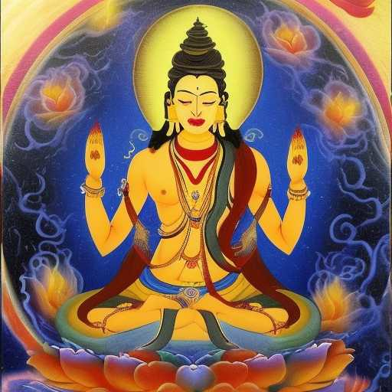
THE ADEPT OF EAST & WEST

पाण्डरवासिनी
She has the magic words to magnetize me to follow my passion
It is said that the skandhas have no ultimate reality

She is that reckless and free adept of both the West and she draws me from the East

Can the result be Avalokiteshvara?

